
NORTHERN EDUCATION DIVISION MOCK.
2025 - 2026 JUNIOR CERTIFICATE EXAMINATION
PROVISIONAL MARKING KEY
PHYSICS
(100 marks)
Instruction Subject Number: J164
- Check that there are 11 printed pages
Section A (20 marks)
Answer all the twenty questions in this section
Encircle the letter representing the correct answer.

- The amount of electric current in a circuit can be measured by using
- An Ohmmeter.
- An ammeter.
- A voltmeter.
- A bulb.

- Which of the following is the law of magnets?
- Like poles attract and unlike poles repel.
- Magnets attract magnetic materials.
- Like poles repel whereas unlike poles attract.
- Magnets repel magnetic materials.

- Which part of a thermos flask prevents heat loss by radiation?
- Still air.
- Vacuum
- Silvery double walled glass.
- Black double walled plastic.

- Identify the lever that has been correctly matched to its order.
- Bottle opener (first order)
- Plier (third order)
- See-saw (second order)
- Wheelbarrow (second order)

- The SI unit of specific heat capacity is,
- Joules per Cubic Meters.
- Joules per Kelvin.
- Joules per Degrees Celsius.
- Joules per Kilogram Kelvin.

- What condition must be satisfied when formulating hypothesis
- The hypothesis must be testable
- hypothesis should be predictable
- The hypotheses should be sustainable
- The hypotheses should be easy to analyse

- Which of the following factors affect electrical resistance?
- Bending of a wire.
- Number of cells.
- Evaporation.
- Nature of a conductor.

- Which of the following is true about a control variable?
A. It varies as other variables vary
B. It is kept constant as you vary the independent variable.
C. It is kept constant as you vary the dependent variables
D. It responds to changes in the independent variable.

- My flash disk has 8 gigabytes. This means that my flash disk has.
A. 8 × 10⁶bytes
B. 8× 10¹² bytes
C. 8 × 10⁹ bytes
D. 8 × 10³ bytes
- Explain why a rotten egg floats on water but a fresh one sinks.
- It is denser than water.
- It is less dense than a fresh one.
- Its average density is greater than the density of water.
- Its average density is less than the density of water.

- Which of the following is the property of Gamma emissions?
- It travels with the velocity of light.
- It is high ionizing since it is just energy with no charge.
- It is deflected by magnetic field.
- It has a helium nucleus.

- Two unequal forces act in opposite directions. What effect do they have upon each other?
- The two forces cancel each other.
- The two forces have no effect on each other.
- The two forces add together.
- The two forces subtract from each other
13. Which of the following are ways of reducing friction force?
1. Polishing surfaces
2. Lubricating parts of machines
3. Using rollers when dragging an object.
4. Using a rough surface.
A. 2, 3 and 4
B. 1,2 and 4
C. 1, 2 and 3
D. 1, 3 and 4
Study the Hazard symbol in figure 1 below and answer the question that follow.
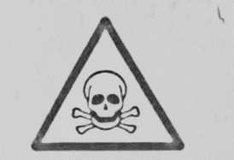
Figure 1
- What is the interpretation for the Hazard symbol drawn above?
- Harmful/ irritant substance.
- Flammable substance.
- Corrosive substance.
- Toxic substance.

Figure 2 below is a graph. Use it to answer the question that follows. 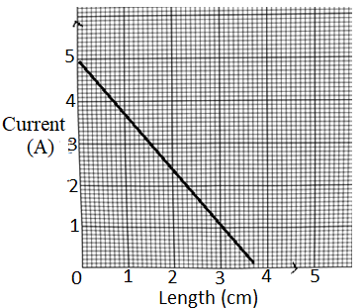
Figure 2
- What is the relationship between electric current and length of a wire?
- As length of a wire increases electric current decreases.
- As electric current decreases, length of a wire decreases.
- As length of a wire increases, electric current increases.
- As length of a wire decreases, electric current increases
- Figure 3 below is circuit diagram showing three cells connected in parallel. If each cell has a voltage of 1.5V, find total voltage in the circuit.

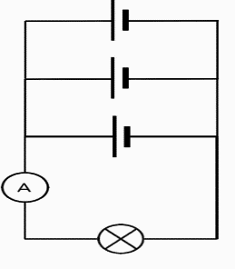
- 1.5v
- 3.0v
- 4.5v
- 0v

- The voltage and current through a device in a circuit are 10V and 2A respectively. Calculate resistance of the device.
- 20ohms
- 5 ohms
- 0.2ohms
- 5 joules
Figure 4 shows an effect of force. Use the information to answer question 11
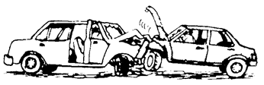
Figure 4
Identify the effect of force shown in the figure
- Moves stationary bodies
- Increases the speed of the moving bodies
- Changes the shape of the bodies
- Decreases the speed of moving bodies
- The effect of electric current associated with a filament wire in a bulb when is on.
- Light effect
- Magnetic effect
- Heating effect
- Chemical effect
- Which of the following is not a set of luminous sources of light?
- Sun, torch with no batteries, candle flame
- Sun, torch that is on, candle flame
- Candle flame, burning plastic, torch that is on
- Sun, burning paper, torch that is on

- Name the subatomic particles that are found inside the nucleus of an atom.
- Electrons and protons
- Electrons and neutrons
- Protons, electrons and neutrons
- Protons and neutrons.

Section B. (50 marks)
Answer all questions in the spaces provided.

- a. Explain why temperature remain constant when ice is melting?
Energy is used to overcome/break the forces of attraction between atoms (1) than increasing kinetic energy (1). b.Figure 5 is a swinging pendulum from point A to point C and then back to point A.
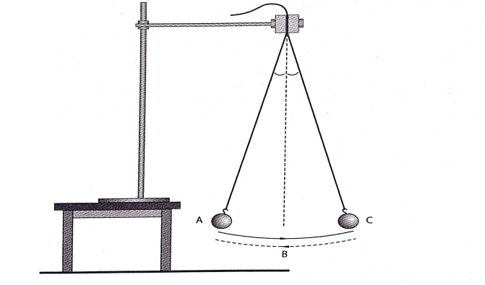
(i). Describe the energy changes that take place as the bob moves from point A to C through the resting point B.
Potential energy to Kinetic energy to potential energy (1)
(ii). In which position does the bob have:
1. Least potential energy B (1).
2. Maximum kinetic energy B (1).
- a. Give two differences between mass and weight.
Mass | Weight
Quantity of matter in an object | Force due to gravity on an object
Measured by beam balance | By spring balance
SI units in grams / kilograms | SI units are Newton
Remains constant from place to place | Changes
(any two, 2 marks)
b. Find the weight of an object on the moon if it weighs 300 N on the earth.
Weight on the moon = 1/6 of weight on the earth (1)
= 1/6 x 300N (1)
= 50 N (1)

- a. State the law of conservation of energy.
Total energy cannot be created or destroyed but can be transformed from one form to another.
(1 mark) b. How much potential energy will a 1000g mass gain if it is raised 25 m above the ground?
- PE = mgh (1)
= 1000x 25 x10 joules (1)
1000
= 250 joules (1)
C. What is the SI unit of work done?
Joule (1 )
- Figure 6 is a diagram showing identical bulbs connected in circuits X and Y.
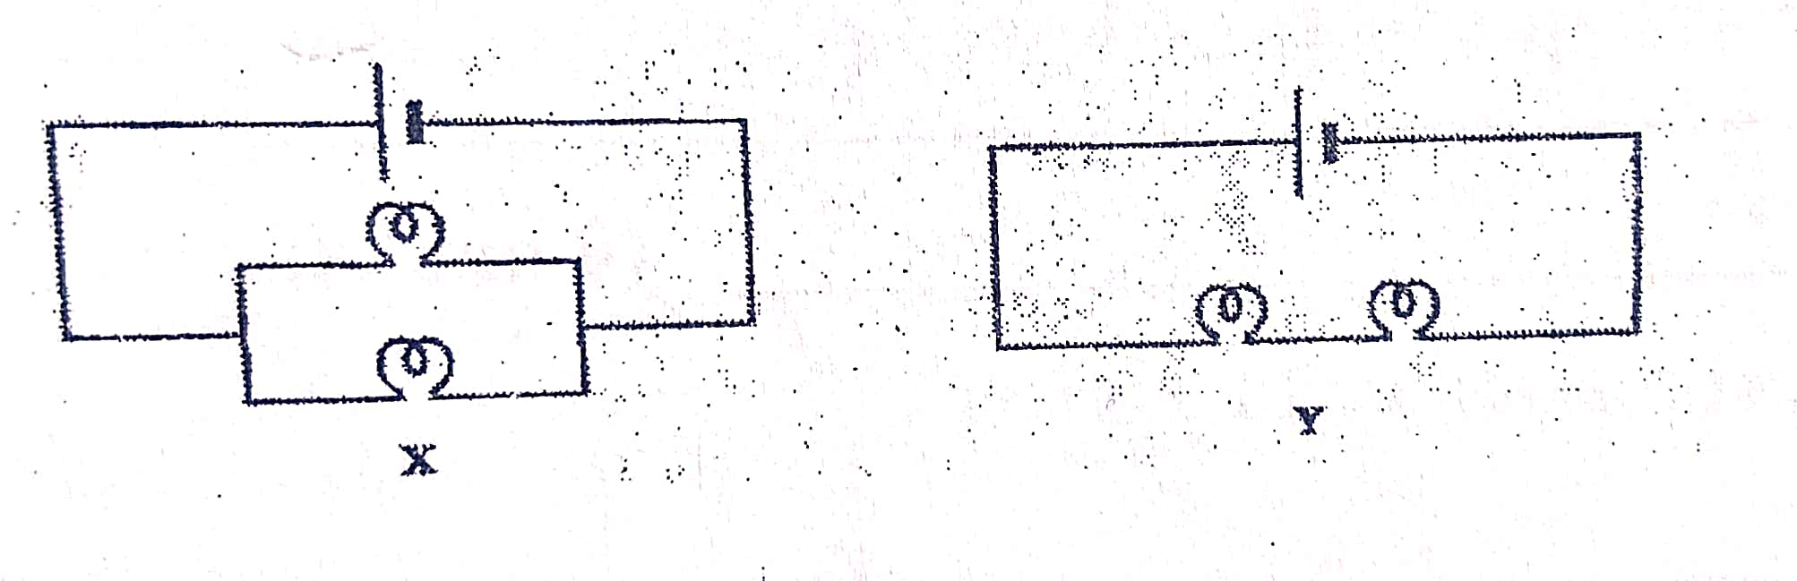
a). In which circuit would bulbs light more brightly?
X (1).
b). Explain your answer in to. 12.(a)
- The same amount of voltage from the cell is provided to each of the two bulbs. (1)
- Hence brighter than in circuit Y where voltage supplied from the cell is divided (shared) amongst the two bulbs. (1)
c. What would be the impact of adding more bulbs in circuit Y.
- The brightness of the bulbs would further decrease (1).
d. Explain your answer to 12. (c).
- Voltage from the power source would be shared by more bulbs (1)
- Hence reducing brightness of the bulb. (1)
e. Which circuit would be suitable for wiring a house? Explain ?
X. Because when one component is removed or damaged the other components would continue functioning. (2 mark)

- Draw two magnets to show direction of magnetic field lines when south poles face each other
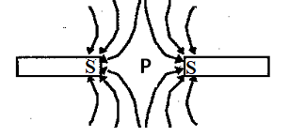 Correct diagram and labelling (2marks)

- a. State any two advantages of using machines.
Accuracy, speed and consistent work
Safe in handling dangerous work
Easy to do work ( any two, 2 marks)
b. A builder mixed 10 g of cement of volume 2.5 cm³ and 30 g of sand and volume 17.5 cm³.
Calculate the average density of the mixture.
Total mass = (10 + 30)g
= 40g (1)
Total volume = (2.5 + 17.5)cm³
= 20cm³ (1)
Average density = total mass
Total volume
= 40/20g/cm³
= 2g/cm³ (1)
- a. Mention any two devices that make use of electromagnets.
Electric bell
transformers
relays
loudcspears and head phones
(any two, 2 marks)
b. Explain why a floating object sink when the temperature of the liquid is raised
Heating causes liquid to expand(1) hence decrease (1) in density of the liquid. The object will have higher density (1)making to sink.
- (a). What is the difference between heat and temperature?
- Heat is a form of energy while temperature is the degree of hotness or coldness of a substance.
- Heat has SI in joules while temperature in Kelvins (2 marks)
b. Figure 7 below shows an experiment on conduction of heat. Use it to answer questions below
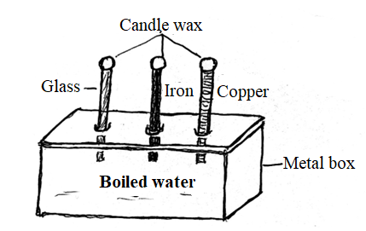

Results: The piece of candle wax on top of copper rod melted first and the
piece of candle wax on top of glass rod melted last.
    - What is the aim of the experiment?
To show conductivity of different metals.
(2 marks)
    - Draw the conclusion of this experiment.
Different metals conduct heat differently when heated equally.
(1 mark)
c. What is the effect of increasing cells arranged in parallel on the brightness
of the bulb?
No effect as voltage remains as of one cell. (1 mark)

- a. State any one way of charging objects.
By contact
Friction
Induction (any one, 1 mark)

b. State the principle of moments.
Sum of clockwise moments is equal to sum of anticlockwise moments. (2 marks)
- a. Define specific heat capacity.
Amount of energy needed to raise the temperature of a one kilogram of a substance by one degree Celsius (1 marks)
b. Calculate the amount of heat required to raise temperature of 2.5 Kg of
Aluminium from 20⁰C to 40⁰C if the specific heat capacity of
Aluminium is 900J/(KgK)
Heat = mass x specific heat capacity x temperature change
= 2.5 x 900 x (40 – 20) (1)
= 2.5 x 900 x 20 J (1)
=45,000J (1)
. Table 2 shows the specific heat capacities of some liquids A, B and C. Use the information to answer questions that follow.
Substance | Specific heat capacity J/kgK
A | 140
B | 4200
C | 2000
Table 2
(i).Which liquid can best be used as an engine coolant?
- Liquid B (1)
(ii). Give a reason for your answer in 28 b.(i)
- It has greatest specific heat capacity (1) hence takes long time to heat up (1).
(iii). Which liquid can best be used in a liquid in glass thermometer?
- Liquid A (1 )
(iv). Give a reason for your answer in 28. b. (iii)
It has the least specific heat capacity (1) hence heats up faster (1)

SECTION C. (30 marks)
Answer all questions in this section in the spaces provided.
- a. Explain how a Periscope works.
Uses two mirrors set at 45 degree angle within a tube (1). Light from the object hits the top mirror (1) which reflects (1) it down the tube and hits the bottom mirror. The bottom mirror reflects it to the observer’s eye (1). The instrument help to see overhead objects or around corners.(1)
b. Describe how a lightning conductor works to protect buildings from lightning. mar
- A lightning conductor placed on top of a building is connected to the ground via a conductor (1)
- The earth being a good conductor of electrons, conducts all electrons from a lightning (1)
- When lightning strikes, it is attracted by the lightning conductor (1)
- The charges then pass through the conductor into the ground (1)
- This process protects buildings from being stricken by the lightening (1)

- a. Explain how volume of an irregular stone can be determined using water, measuring cylinder and a string.

- Half fill the measuring cylinder and note the initial volume of water.
- Carefully immerse the stone while tied to a string into measuring cylinder.
- Note and record the new volume after immersing the stone.
- Find volume of the stone by subtracting first volume from final volume.

(5 marks)
b. Describe an experiment that could be carried out to show that electric current has a chemical effect.
Dissolve copper sulphate in water in a container.
Pour the solution in a beaker
Dip two electrodes into the solution.
Join power source to the two electrodes
Leave the set up for a few minutes
Note the coating on the electrodes
The presence of coating or evolution of a gas, show that flow of current in an ionic compound has chemical effect. (5 marks)
- Describe an experiment to show that when different metals are heated equally they expand with different amounts.
- Take a bimetallic trip and source of heat.
- Observe and note the shape of the metal
- Heat the bimetallic strip using source of heat gradually
- Note and observe the change in shape.
- Compare the shape
- The bending of the strip show that different metals expand differently when heated equally. (5 marks)
b. Explain how sea breeze occurs.
At sea level, during the day, (1) land is heated faster than water (1). This causes density of air to decrease and rise up (1). Cold air from the sea blows (1) towards the land (1).
(5 marks)
END OF QUESTION PAPER

